**6/17/20 Class Notes**

Section 11.1 Boolean Algebra

Homework pages 756 – 757 #1, 3, 5a, 11, 15.

Boolean algebra provides operations for working with 0’s and 1’s.

Boolean Operations

THE COMPLEMENT





THE BOOLEAN SUM ()









THE BOOLEAN PRODUCT()









Order of Operations is:

1. Complement
2. Multiplication
3. Addition

Example: Find the exact value of 

Example: Translate into a logical equivalence.

Example: Translate into a Boolean algebra identity.

Boolean Expressions and Boolean Functions

Example: The function is a Boolean function of degree 2.We say  . We give all possible outputs of this function in a table.

Example: Find the values of the Boolean function represented by , .

All Boolean functions of degree 2 can be represented as follows:

There are functions of degree n .

Boolean Identities

Example: Verify that the distributive law is valid using a table.

Example: Prove the absorption law using other identities from Table 5.

Section 11.2 Representations of Boolean Functions

Homework page 760 problem numbers 1, 3, 7

Example: Find Boolean expressions to represent the functions  and  in the table below:







ifor then 



Example: Find the sum-of-products expansion of  . Each term of the sum must include AND AND.





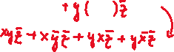





Example: Find the sum-of-products expansion of .

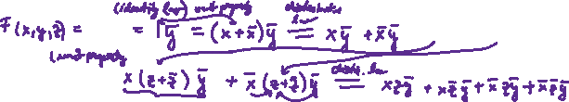

Functional Completeness



What is the minimum number of operations are really necessary to express a Boolean function?

We see that we can express Boolean functions using . Can one be eliminated?



 this expression of the sum in terms of products and complements makes the OR operation redundant.



 this expression of the product in terms of sums and complements makes the AND operation redundant.

We can also express all Boolean functions in terms of one operation.

The operation NAND represented by “|” is defined as:









Since and we conclude that all Boolean functions can be expressed in terms of just ONE operator, in this case, NAND.

Section 11. 3 Logic Gates

Homework Pages 765 – 766 # 1, 3, 5, 6, 7.

Example: Construct circuits that produce the outputs a) , b) 



a) 



b) 



Example:

Give the output for the circuit:



<https://support.desmos.com/hc/en-us/articles/212235786-Supported-Functions>

<https://www.desmos.com/calculator/btn7ufopnw>

